**Computer Networks**

**Lab 3a**

**Wireshark Lab: UDP v8.0**

**Student Name: Phạm Ngọc Sang**

**Student No: 1813810**

1. **Select one UDP packet from your trace. From this packet, determine how many fields there are in the UDP header. (You shouldn’t look in the textbook! Answer these questions directly from what you observe in the packet trace.) Name these fields.**

Answer: 4 fields: Source Port, Destination Port, Length, Checksum

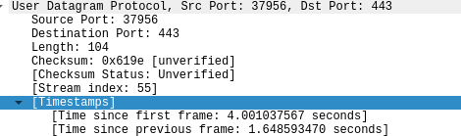

1. **By consulting the displayed information in Wireshark’s packet content field for this packet, determine the length (in bytes) of each of the UDP header fields.**

Answer:

Source Port: 2 bytes

Destination Port: 2 bytes

Length: 2 bytes

Checksum: 2 bytes

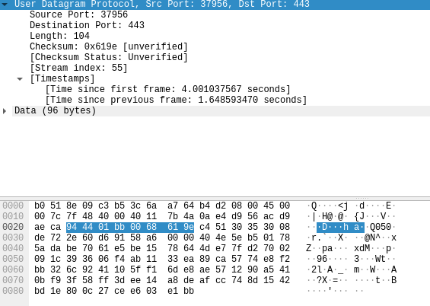

1. **The value in the Length field is the length of what? (You can consult the text for this answer). Verify your claim with your captured UDP packet.**

Answer: 104 bytes

The value in the Length field is the length of UDP segment including header and data.

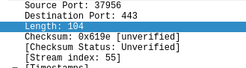

1. **What is the maximum number of bytes that can be included in a UDP payload? (Hint: the answer to this question can be determined by your answer to 2. above)**

Answer: 65527 bytes

1. **What is the largest possible source port number? (Hint: see the hint in 4.)**

Answer: 65535 bytes

1. **. What is the protocol number for UDP? Give your answer in both hexadecimal and decimal notation. To answer this question, you’ll need to look into the Protocol field of the IP datagram containing this UDP segment (see Figure 4.13 in the text, and the discussion of IP header fields).**

Answer: The protocol number for UDP:

in hex: 0x11

in dec: 17

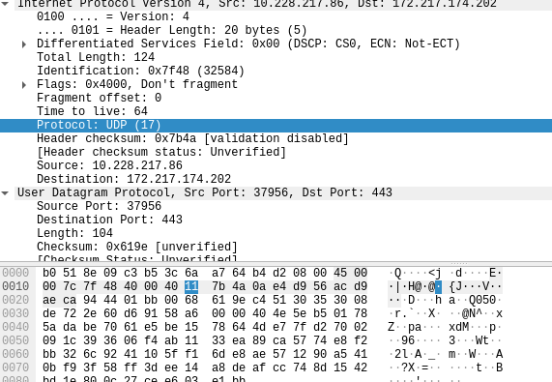

1. **Examine a pair of UDP packets in which your host sends the first UDP packet and the second UDP packet is a reply to this first UDP packet. (Hint: for a second packet to be sent in response to a first packet, the sender of the first packet should be the destination of the second packet). Describe the relationship between the port numbers in the two packets.**

Answer:

The Source port of the UDP packet sent by the host is the same as the destination port of the reply packet.

The Destination port of the UDP packet sent by host is the same as the source port of the reply packet.

